< Ambassador Says North Macedonia> a model country for ethnic reconciliation in the Balkans
- Published Date: May 8, 2023
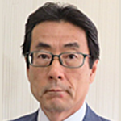
Former Ambassador of Јапан to North Macedonia Hironori Sawada
In an interview, Ambassador Hironori Sawada, who recently returned to Japan after serving as Ambassador of North Macedonia from November 2020 to December 2022, talked about the characteristics and appeals of North Macedonia, what he experienced and worked on during his tenure, and his relationship with Japan and prospects.
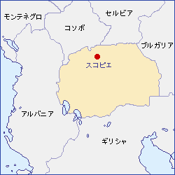
―What kind of country is North Macedonia? What is its attraction?
<Crossroads of the Balcans>
People often ask, "Where is North Macedonia?", but it seems that the easiest way to explain it is "a country that is part of the former Yugoslavia and surrounded by Greece, Bulgaria, Serbia, etc." These countries are historically closely related to the origins of today's North Macedonia.
The name of the country of North Macedonia comes from the ancient Macedonian kingdom of Alexander the Great. Since ancient times, "Macedonia" has been a key point of east-west transportation, and the history of rule has changed with the Roman Empire, the Byzantine Empire, and the Ottoman Empire, and during that time, it was also ruled by the Bulgarian Empire and the Kingdom of Serbia in the Middle Ages. At the end of the Ottoman Empire, while neighboring countries became independent one after another, "Macedonia" was said to be a power vacuum, and Greece, Bulgaria and Serbia divided their territories (Balkan Wars). "Macedonia", which became Serbian territory at this time, became the Republic of Macedonia in the Federation of Yugoslavia after World War II. It became independent as the "Republic of Macedonia" in 1991, but Greece opposed the name due to historical reasons, and after long negotiations, it became the "Republic of North Macedonia" in 2019.
< Fusion of history, culture and nature>
Due to the historical background where many ethnic groups came and went, it is a country rich in flavor with diverse cultures. Home to ancient Roman ruins, Byzantine churches, and the Old Bazaar, remnants of the Ottoman Empire, the country is blessed with scenic land, rich nature (sunshine 300 days out of the year), and delicious ingredients and wine.
Lake Ohrid (pictured), which separates Albania from the border, is Europe's oldest ancient lake and is one of North Macedonia's top tourist destinations with magnificent views surrounded by mountains. It is also the capital of the medieval Bulgarian Empire, the cradle of Slavic-Christian culture, and a treasure trove of Byzantine culture, especially icon art. The Ohrid region is a fusion of nature and culture, and is one of the few UNESCO heritage sites in the world. There is also an exchange with Lake Biwa, which is also an ancient lake.
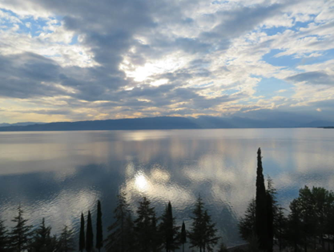(Photo) Lake Ohrid, a World Heritage Site
<Model of ethnic reconciliation>
65% of the population is of Macedonian descent, but it has a strong coexistence with Albanians (25% of the population). Due to the influence of the Kosovo conflict, an influx of 300,000 Albanians and clashes with the national army occurred in 2001, but a settlement was reached through Western mediation (Ohrid Agreement), and policies such as language, education, and employment are being adopted in consideration of the Albanian community, and it is said to be a "model of ethnic reconciliation" in the Balkan region, where there are many conflicts. Successive governments have consisted of a coalition of major Macedonian parties and minor Albanian parties, and Albanian parties have played an important role in the current government (holding influential posts such as Speaker of the National Assembly, Deputy Prime Minister, Foreign Minister, Minister of Finance, and Minister of Economy). Nobel Peace Prize winner Mother Tereza was born in Skopje of Albanian descent, and there is a memorial museum of Mother Tereza in Skopje.
＜EU Membership is a long-cherished wish of North Macedonia>
Joining the EU has been our top priority since independence, and we are advancing reforms to that end with the cooperation of other countries. In 2005, it became a candidate country for EU membership, but the start of negotiations was delayed due to the name issue with Greece and the history issue with Bulgaria, and finally started in July 2002. There are many difficult issues that remain, including constitutional amendments, and it is expected that there will be a long way to go before we can join the Constitution. In my resignation speech, I said in front of Foreign Minister Osmani, "North Macedonia has a history of overcoming difficulties many times in the past, and I believe that it will definitely overcome difficulties as it moves toward EU membership, and I am supporting Japan." It joined NATO as the 30th member in March 20.
What is the relationship between North Macedonia and Japan?
<Memories of architect Kenzo Tange>
North Macedonia is a very pro-Japanese country. One of the major reasons for this is the contribution of architect Kenzo Tange. In 1963, there was a massive earthquake in Skopje, and Kenzo Tange played a central role in the urban reconstruction plan, which is still strongly remembered by the citizens. Skopje has since been modernized, but you can see things like Skopje Central Station/Bus Terminal, designed by Kenzo Tange (pictured). In 2020, Kenzo Tange commemorative stamps were issued. In addition, 23 years mark the 60th anniversary of the Skopje earthquake, and commemorative events are planned.
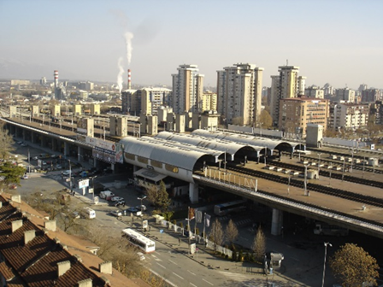Skopje Central Station/Bus Terminal designed by Kenzo Tange
< Mr. Costa Baranov introduced Japan during the former Yugoslavia>
In 1967, the exhibition of medieval icons was held in Japan, and many works from the Icon Museum in Ohrid were exhibited. The renowned historian Costa Balabanov, who served as general director at the time, was deeply impressed by the history, art and culture of the Japan during his six-month stay in Japan, and upon his return, founded the Macedonian Japan Friendship Society. In addition to introducing the culture and art of Japan that were unknown at the time, we also disseminated news about Japan. This contributed to the Macedonian interest in Japan and became the basis of today's pro-Japanese sentiment (Balabanov subsequently served as Honorary Consul General of the Japan and received the Japan Foundation Award).
<Western Balkans Cooperation Initiative>
Under the "Western Balkans Cooperation Initiative" proposed by then-Prime Minister Abe in 2018, Japan supports the socio-economic development of the Western Balkans for European integration through political dialogue, economic cooperation, support for Japan companies, and support for ethnic reconciliation (Note: The Western Balkans are six countries: Serbia, North Macedonia, Albania, Bosnia and Herzegovina, Montenegro, and Kosovo). Since the independence of North Macedonia, the Japan government has provided large-scale grant aid, mainly in the provision of medical equipment (most recently, support for coronavirus countermeasures since 20 years). In addition, since 1996, through the Grant Aid for Grassroots Human Security, we have implemented support programs to schools, hospitals, local governments, etc., and have been highly evaluated. JICA is also actively engaged in dam construction (yen loans), environmental protection, support for entrepreneurs, and cultural grants (provision of musical instruments, sound, and lighting equipment to the National Opera and Ballet).
<Special relationship of trust>
North Macedonia shares common values with Japan that value the rule of law, freedom, and democracy, and has expressed support for the Free and Open Indo-Pacific initiative advocated by the Japan. In recent years, it has become essential to build cooperative relationships in the international community as the international situation changes, but North Macedonia has always shown understanding and cooperation with Japan. The traditional sense of affinity for Japan, Japan's economic cooperation, and cooperation in the international arena can be said to have a special relationship of trust between the two countries. Foreign Minister Osmani's visit to Japan, which I will discuss later, symbolized this.
―During your tenure as Ambassador, what was the most important work you put into and what left an impression on you?
< "Grassroots Assistance": Small Aid Has a Big Effect>
Particular emphasis was placed on Grant Aid for Grassroots Human Security (hereinafter referred to as "Grassroots Grant Aid"). Soon after I arrived in November 2020, there were signing ceremonies for 10 "Grassroots Grant Aid" projects, and I visited local cities, and I realized that "Grassroots Grant Aid" was very successful and highly evaluated. North Macedonia has received enormous support from the EU as a candidate country for EU membership, but most of it is used for large-scale infrastructure construction such as roads, and it does not reach social infrastructure development such as medical care and education. Grassroots Grant is a small project, but in a small country like North Macedonia, it has had a tremendous effect and is appreciated. The following year, we worked even harder and conducted 13 projects. From 1996 to 2022, we have supported a total of 171 projects with €8.5 million.
"Grassroots Gratuity" is also helping to promote understanding of Japan. Many schools and kindergartens are repairing the roofs, windows and doors of school buildings, which is an opportunity for children to learn about Japanese and Japan culture. These experiences will surely be a source of mutual understanding.
At the end of November, just before I left, I was named "You are this year's Man of the Year." I received the news. I was surprised by the suddenness, but when I asked him, he said that his contribution to the development of education, healthcare, and the environment in North Macedonia over the past two years, especially "grassroots grants", was highly evaluated. At the award ceremony, I gave a speech in Macedonian and said, "I would like to share this award with the Japan government, the people, all the embassy staff and my wife, who has always supported my diplomatic activities" (pictured).
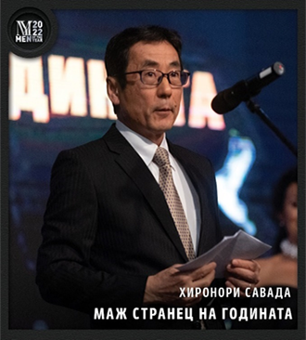Man of the Year Award Ceremony
< Political Dialogue>
In order to promote the Western Balkans Cooperation Initiative, I thought that high-level political dialogue was important. Although it is extremely rare for Foreign Minister Osmani to visit countries outside of Europe, he too has been eager to visit Japan since the beginning of his tenure. After several rearrangements amid restrictions on the movement of dignitaries due to the Corona disaster, I finally visited Japan in May 2022 (this was the first foreign minister's visit from the Western Balkans after the coronavirus). In his welcome speech at my departure reception, Foreign Minister Osmani referred to his relationship with me and recalled, "My visit to Japan was an important epoch-making event for bilateral relations." It was a moment when I realized that the personal relationship of trust I had built with Foreign Minister Osmani had led to the strengthening of the relationship between our two countries (photo).
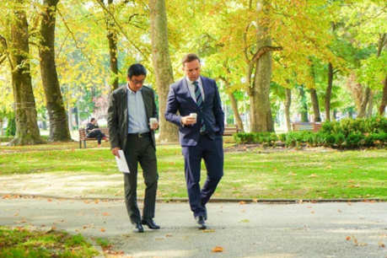Pictured: With Foreign Minister Osmani walking through Skopje City Park
< cultural exchange >
When I first arrived, it was really hard to have limited interaction due to the Corona disaster, but I gradually resumed my activities and there are some memorable events. In February 2022, the National Opera and Ballet organized a special concert "Thank You" to thank Japan for their cooperation. At the end of the concert, the leading North Macedonian tenor singer greeted us with a Japanese and sang "Hometown" in Japanese, which was very moving. In the latter half of the same year, Japan artists and musicians visited the city, and their activities became more active. 2024 marks the 30th anniversary of diplomatic relations between Japan and North Macedonia. I look forward to further deepening exchanges.
< Business Dialogue>
In order to build business relationships, we visited various leading companies in North Macedonia and also explored the investment possibilities of Japan companies. So far, there have been no significant Japan investments and limited trade relations, but North Macedonia has an excellent investment environment (one of the best in the world according to the World Bank's investment climate) and we expect Japan to invest. During his visit to Japan, Minister Osmani co-hosted the North Macedonia Business Seminar with JETRO and called on Japan companies to invest. Some Japan companies are beginning to show interest in investing in North Macedonia, and I think a major issue will be how Japan will increase its presence in economic relations in the future.
-Was there anything that you felt strongly about working overseas?
I studied Portuguese at university, and even after joining the Ministry of Foreign Affairs, I trained in Portuguese and worked mainly in Portuguese-speaking countries, so I didn't have much trouble with words. Macedonian and Albanian are mainly spoken in North Macedonia. English is often sufficient for work, but if you don't know Macedonian, you can't understand newspapers and TV at all. So I decided to take the plunge and try my hand at Macedonian. It was my first experience with Slavic language, and I had a hard time getting used to the Cyrillic alphabet, but about six months after I started studying, I tried to give a speech in Macedonian. I had many opportunities to give speeches as an ambassador, such as the signing ceremony and handover ceremony of the "Grassroots Grant" and the opening of cultural events. I think this was very useful for studying the Macedonian language, and the local media and government officials were very pleased. If I could use Macedonian better, I think the quality and quantity of networking and information gathering would have expanded.
The Ministry of Foreign Affairs has specialists in nearly 50 languages, and in the languages of the Balkans there are specialists in Bulgarian, Romanian, Serbian, Croatian, Slovenian and Greek, but not in Macedonian, Albanian. The purpose of language training is to learn the history and culture of a country at the same time as to acquire a language, which is an important factor in building relationships with that country, so I hope that in the future we will develop specialists in Macedonian and Albanian.

