Host Town Exchange Brought a Medal for the First Time in 20 Years

(Chigasaki City, Kanagawa Prefecture and North Macedonia)

December 24, 3rd year of Reiwa（2021）

Published on the website of the Ministry of Foreign Affairs

**At first**

When Chigasaki City was selected as the Host Town of North Macedonia, most Chigasaki citizens may have wondered, "Where is North Macedonia?" It's no wonder that it is a new country that became independent in 1991. However, as a result of a variety of Host Town exchange projects in preparation for the Tokyo Olympic and Paralympic Games (hereinafter referred to as the Tokyo 2020 Games), Chigasaki City and its citizens have come together to say that there is no one in Chigasaki who does not know about North Macedonia.　This shows how important people-to-people exchanges play in mutual understanding between the two countries, and at the same time, they are a great asset for international exchanges. In this article, I would like to introduce some of the Host Town exchange activities in Chigasaki City, touch on the charm and national character of North Macedonia, and also express my impressions.

1. **The charm of North Macedonia wins the hearts of citizens**

I have visited Chigasaki City several times, and each time I visited, the Host Town exchange activities have become more exciting, and I realized that the recognition of North Macedonia is changing dramatically as a result. Through the Special Exhibition of the Republic of North Macedonia, the Mother Teresa Panel Exhibition, Macedonian wine, local cuisine, and the exchange of letters, it seems that the unknown charms of North Macedonia, such as history, nature, culture, and art, gradually won the hearts of the citizens of Chigasaki.　The name "Macedonia" comes from the ancient Kingdom of Macedonia under Alexander the Great, but it is located in the center of the Balkan Peninsula and has left a unique history and culture as a result of the coming and going of many peoples as a hub of east-west transportation since ancient times, and they are beautifully integrated with nature. The more you know about it, the more fascinating it is.

**2 Children learn about history and culture through painting contests**

Among the Host Town exchanges in Chigasaki City, the one that left a particularly strong impression on me was my participation in the Bitola Painting Contest. With a history of 30 years, a junior high school in Chigasaki City participated for the first time in which children from all over the world participated, and won the school award (Golden Brush) and individual prize.　However, the significance of this exchange does not end there. Bitola is a historic cosmopolitan city that flourished for a long time from Roman times to the era of the Ottoman Empire, and its appearance and atmosphere are still the charm of the city. I was invited to the award ceremony and later visited Chigasaki City Hall to hand it to the students, and I was very impressed to learn that the children had studied the deep history and culture of Bitola through their participation in this painting contest. It is a very valuable experience for children to learn about the history and culture of the other country through such exchanges, and I hope that they will cherish that experience for the future. I have heard that Chigasaki City is recruiting applicants to participate in the Bitola painting exhibition this year again, and I am very much looking forward to seeing how this exchange will develop in the future.

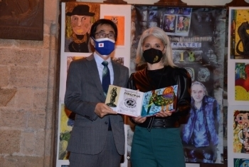

Bitola Painting Contest Award Ceremony

**3 A enthusiastic cheers through the wrapping bus supported the players**

Even though it is a Host Town, unfortunately due to the Corona pandemic, we were not able to interact with the players and watch the matches that we were looking forward to. Therefore, Chigasaki City supported the players by wrapping them on a community bus and introducing them. Perhaps because of this, one of the athletes introduced on the bus, Dejan Georgievski (over 80 kg category in taekwondo), won the silver medal. It was North Macedonia's first medal in 20 years and its first ever silver medal in history. (After that, a version of "Congratulations on the silver medal" appeared on the wrapping bus.) In North Macedonia, there is a love for traditional Japan sports such as judo, kendo, and karate, and the athletes especially value the discipline. The enthusiastic cheers of the citizens of Chigasaki must have touched Deyan's heart remarkably. Mr. Dimeski, President of the North Macedonian Olympic Committee, who led the group, also praised the Host Town activities of Chigasaki City after returning to North Macedonia.

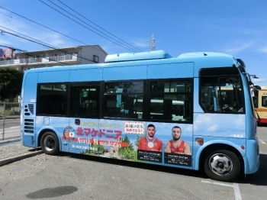

Wrapping bus running through Chigasaki City

**4. From Host Town Exchange to Bridging the Two Countries**

In my previous assignment in Angola, I supported activities to register Tamana City in Kumamoto Prefecture as a Host Town. Due to the postponement of the Tokyo 2020 Games for one year, I was transferred to North Macedonia during that time. I was relieved and moved that they came even during the coronavirus pandemic when I saw the Angolan athletes entered the stadium with the Tamana City mascot "Tama Nyan Mask" given by Tamana City during the Opening Ceremony, being introduced as "Tamana City in Kumamoto Prefecture is the host town". And I feel very fortunate to be involved in the Host Town exchange between the two countries.　In both North Macedonia and Angola, we were able to have such wonderful exchanges starting from scratch, thanks to the vitality of people-to-people exchanges. And that exchange has the potential to lead to the future. I strongly hope that international exchange, which began as a result of the Host Town exchange, will continue to develop and become a bridge between our two countries.

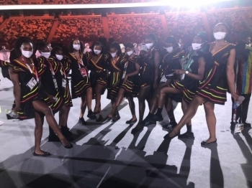

The Angolan Olympic team marched to the venue wearing a tama nyan mask